Car accident severity
Report

IBM Data Science Course – Capstone Project

Yiyi Ji

20th September 2020

Introduction

Car accidents are a massive global issue that often result in injury, disability, death and property damage. It has financial costs to society and individuals involved. United nations have predicted that in 2020 car accident deaths and injuries will exceed HIV/AIDS as a burden of death and disability, and the fifth leading cause of death by 2030.
A number of factors contribute to the risk of collisions, including weather conditions, road conditions, light conditions, speed of operations, use of alcohol or drugs, etc. By analyzing these factors, one could predict the severity of the accidents.
The accident severity predictions could be used to alert the drivers, the competent authorities whether a day has or not high severity factors, so the drivers could avoid driving or taking alternative routes and the authorities can prevent accidents by taking necessary measures (for instance repairing roads, improving lightening, better design intersections, etc.) or prepare for the causalities by allocating resources in advance.

Data

To build a machine learning model to predict the severity of car accidents we are going to use the road collision data from Seattle Department of Transportation, Traffic Management Division from 2004 to present. The data can be downloaded here: https://s3.us.cloud-object-storage.appdomain.cloud/cf-courses-data/CognitiveClass/DP0701EN/version-2/Data-Collisions.csv.

  - Data description
The dataset contains road collision data from Seattle Department of Transportation, Traffic Management Division from 2004 to present. Our target is the car accident severity: 1. property damage only or 2. injury. The dataset has 37 features and 194673 entries. A detailed description of the dataset can be found here: https://s3.us.cloud-object-storage.appdomain.cloud/cf-courses-data/CognitiveClass/DP0701EN/version-2/Metadata.pdf.
Some features are reductant, as they repeat information of other features, some have irrelevant information for the prediction of car accident severity, and some other features have high degree of missing values (66%-95%), thus these features were dropped from the dataset. In the features with few null values, instead of replacing the null values with mean, nearest value or most frequent value, the null values where dropped and the rest maintained in the dataset.
Some features that are useful for our prediction model are: location (given in geographical coordinates), weather condition, road condition and light condition.
Lastly, the dataset is unbalanced as there are 136485 cases of severity 1 (property damage only) and 58188 cases of severity 2 (injury). It needs to be balanced before be used in machine learning models to avoid biases.

Methodology

  - Data cleaning
Drop reductant or not important features for car accident severity prediction:
- 'OBJECTID': ESRI unique identifier - not important
- 'INCKEY': A unique key for the incident - not important
- 'COLDETKEY': Secondary key for the incident - not important
- 'REPORTNO': not important
- 'STATUS': not important
- 'LOCATION': address in text, the location coordinates 'X' and 'Y' can be used instead
- 'EXCEPTRSNCODE': not important
- 'EXCEPTRSNDESC': not important
- 'SEVERITYCODE.1': repeated info of label 'SEVERITYCODE'
- 'SEVERITYDESC': repeated info in text of label 'SEVERITYCODE'
- 'INCDATE': repeated info of feature 'INCDTTM'
- 'SDOT_COLDESC': repeated info in text of feature 'SDOT_COLCODE'
- 'SDOTCOLNUM': A number given to the collision by SDOT - not important
- 'ST_COLDESC': repeated info in text of label 'ST_COLCODE'

Drop features that have majority NaN values:
- 'INTKEY' - 66% NaN
- 'INATTENTIONIND' - 85% NaN
- 'PEDROWNOTGRNT' - 98% NaN
- 'SPEEDING' - 95% NaN

Drop remaining NaN values:
We could replace the NaN Values by replacement methods (mean, nearest value, most frequent value). But I chose to drop all NaN values to have an unbiased dataset.

  - Data visualization and pre-processing

Accident trends by date
The date and time stamp of the accidents in ‘INCDTTM’ were processed to get access only to the months of accident occurrence to see if there is a monthly trend. By the graph below we see that the month influences the number of car incidents.
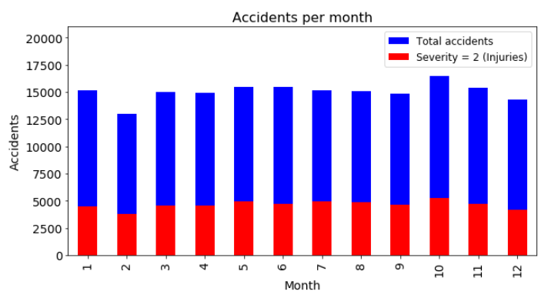

The date and time stamp of the accidents in ‘INCDTTM’ were processed to get access only to the week days of accident occurrence to see if there is a daily trend. By the graph below we see that the week day influences the number of car incidents.

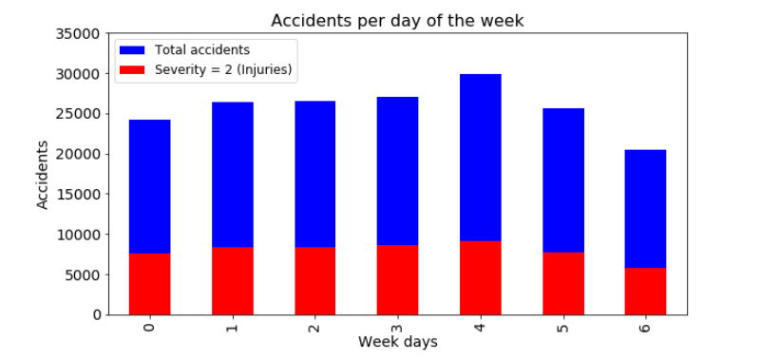

Accident by weather condition
It seems that the majority of the accidents happens during clear, raining or overcast days. We can keep these three features and group all the other in 'weather_others'.
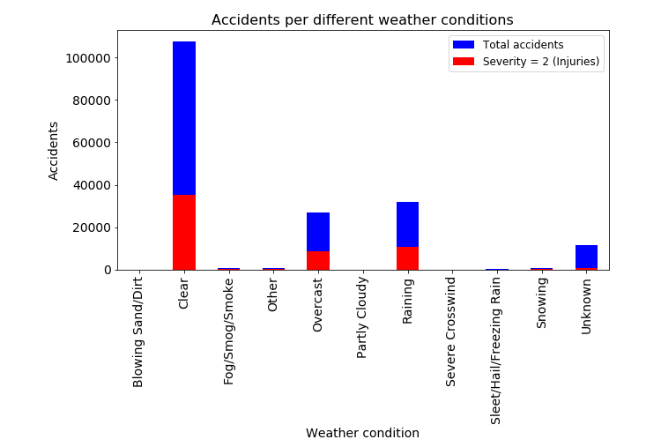
Accident by road condition
It seems that the majority of the accidents happens on dry and wet road conditions. We can keep these two features and group all the other in 'road_others'.
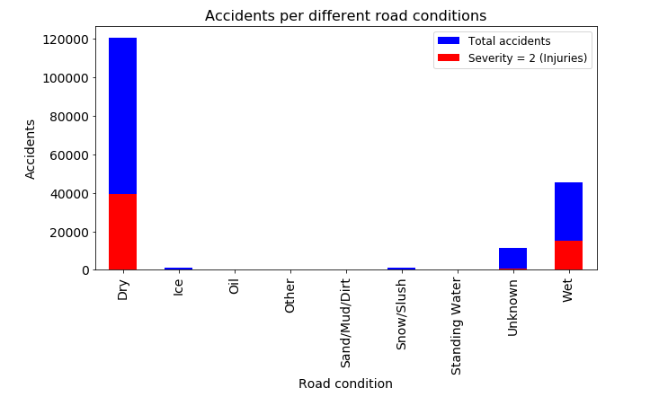

Accident by light condition
It seems that the majority of the accidents happens on Daylight and Dark - Street light on conditions. We can keep these two features and group all the other in 'light_others'.
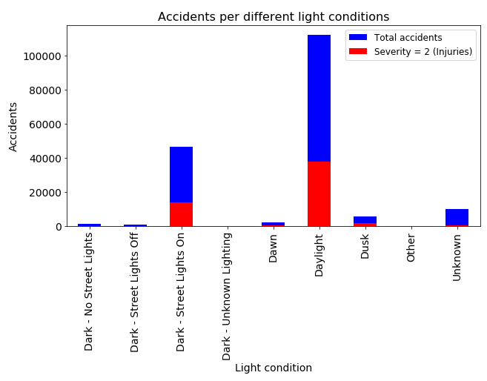
Accident by geolocation
All accidents

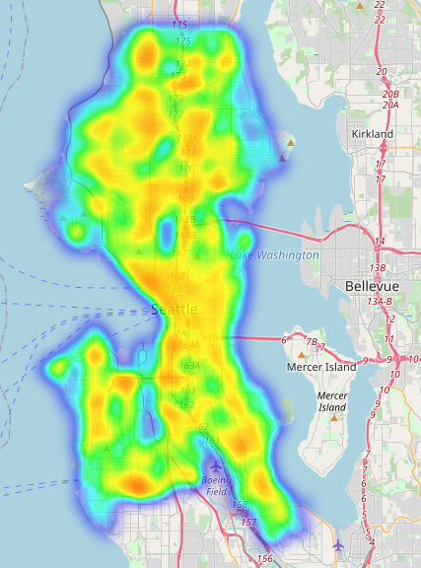

Severity 2 (Injury) accidents
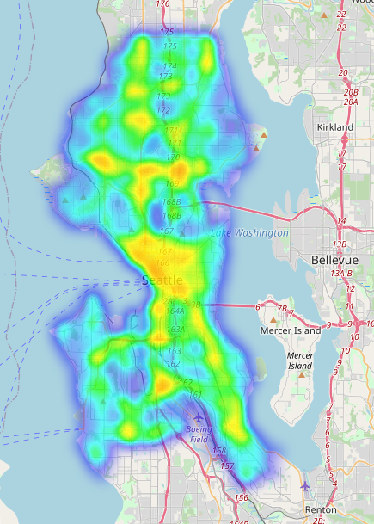

  - Machine Learning modeling

Pre-processing
Balancing the data
After data cleaning there are 124258 cases of severity 1 and 55809 cases of severity 2. To balance the data, I diminished the severity 1 cases to 55809.

Feature Selection
For our model, we are going to use the following features:
- Weather condition
- Road condition
- Light condition
- Geolocation

Modelling
Three supervised machine learning algorithms are used to predict the severity of car accidents:
- K-nearest Neighbor
- Decision Tree
- Logistic Regression
Support Vector Machine algorithm is not used here as the data set is very big and this algorithm is very resource expansive and will take a long time to run.
From the dataset, 80% of it will be used for training the models and the rest 20% will be used for testing. This results in a training set of 89294 events and testing set of 22324 events.

Results

Algorithm | Jaccard |  |  | F1-score | Log Loss
KNN |  | 0.655745 | 0.621063 |  |  | NaN
Decision Trees |  | 0.642028 | 0.622552 |  |  | NaN
Logistic Regression |  | 0.688232 | 0.561136 |  |  | 0.62052

Discussion

We cleaned the data by dropping features with reductant and with high levels of null values, preparing for a clearer dataset.
In the data exploratory analysis, we visualized car accident trends at different months. There we see that October has highest accident rates and February has lowest accident rates.
Visualizing car accidents trends at different week days, we see that more occurrences on Fridays and less occurrences on Sundays.
At different weather conditions, the majority of car accidents occur at clear days.
At different road conditions, the majority of the accidents happens on dry road conditions.
At different light conditions. the majority of the accidents happens in day light.
By geolocation, the majority of the accidents happen in downtown.

The best model was logistic regression, with 0.69 Jaccard score.

Recommendations
Month and week day could be incorporated in the model to increase the performance of the models. It wasn’t included because its computationally heavy and takes very long time to process so many features.

Conclusion

​A supervised machine learning model using logistic regression algorithm was built to predict accident severity based on weather, road and light conditions as well as geolocation.

